

**Technossus Manager Application Requirements Specifications**

Ryan Bell, Ada Guan, James Louie, Jay Patel, Carrie Shen

Comments in blue

Table of Contents

Revision History

Introduction Scope Audience

Overview/Executive Summary Application Context and Constraints Use Cases

Functional Requirements Specification

Software Qualities and Non­Functional Requirements

Assumptions and Risks

Priorities and Implementation Phases

Future Directions and Expected Changes

Revision History

|  |  |  |
| --- | --- | --- |
| Date | Version | Notes |
| 1/23/15 | 1.0.0 | First Draft |
| 2/1/15 | 2.0.0 | Second Draft |

Introduction

This document will provide information and specifications for Technossus Manager mobile application software program. Any functions of the Technossus Manager are outlined in this document. This application will serve as a resource management tool for the company. In this context, the resources that the company manages with this system are employees, clients, and projects, as well as the connections between each of these items. The existing system that Technossus uses is functional, however it is not optimized for mobile use. The client desires a system that will be able to be used on-site when speaking with a potential client, and provide the individual using the system with vital information regarding the availability, skill, and current and past projects of all employees. This system is project management software that will implement a pre existing system into a mobile application.

**Scope**

This application will be used for internal use within the company Technossus. All levels of employees involved with software development will have access to this application, although each level will have their own goals and purposes for this application. However, employees or managers that are on site with a client, to allow them ease of access to vital information in the field, will use this application. The scope of this project is to create a front-end, mobile, interface to display the data from the framework that is already implemented online. In this context, the data that will be implemented in the application is information regarding people, clients, and projects, with a particular focus on which people are working on which projects and when they will be available.

Overview/Executive Summary

This mobile application will provide vital resource management and additional communication methods to all levels of Technossus’ management infrastructure. This application is designed be flexible enough for any level of employment to use for their specific uses. The two main functions of this application is to provide a method of searching for available resources, people, and allocating them in appropriate projects, as well as to serve as a dynamic feed of updates pertaining to projects. This application will serve as a way to make the system that is already in place much more accessible by employees and managers who are using their mobile device to access the information.

This application will only be used by Technossus employees, with each employee using their own personal credentials to login and out of the application. This database and authentication will not be in scope of this application, as it will use pre­existing technologies for these functions.

Two examples of use at different levels of the corporate structure are as follows. The CEO of the company could use the application to ensure that project managers are appropriately placing employees onto development teams based on their skill and availability, and no other factors. Developers will use this tool to view any actions or posts made by their teammates on their project, just by looking at their live feed.

Application Context and Constraints

The application is limited in several aspects, including functionality based on pre established systems and security and credentials. Because the application operations parallel the databases, the application must be maintained to keep up with any and all updates to the databases. Log in credentials are not managed by the application itself, but instead we will be using a tool to communicate with the back end of the pre existing web application to validate employee login credentials.

The different views of the application consists of many various elements. A live feed of the most relevant information, including any posts or actions made by teammates on the project pages that an individual is a member of. A project view, that allows you to see the details of a project and the communication associated with that project, any posts or actions taken by another team member. A list of all developers and their managers with their details, including their contact information, current availability, and a self uploaded image of the employee. The final main element is a list of clients that have projects with the company. This list will be comprehensive and will allow users to view any projects that are currently ongoing with this company. In addition to these main screens of the application, there will also be various connections between the three main “headers” of the application. For example, an individual’s page will include current and past projects. A sidebar will be accessible throughout the application that will provide easy navigation to different parts of the software, allowing the user to readily access any and all necessary information. There will also be a search functionality provided to the user, this will use a simple text based search to find information throughout the system and present the information to the individual in an organized format. The goal of this application is to provide a tool to the company that will improve team building and communication.

The application is already a fully-fledged web app, but Technossus is in need of a mobile version that can be used in the field or on the go. This application will be designed to run the Android mobile operating system. However since we are implementing this application using the cross platform development tool Xamarin, there exists a capability that it can be developed to be cross platform in the future. It is important that we leave the application open for this expansion due to the wide variety of mobile operating systems in use today.

Mockup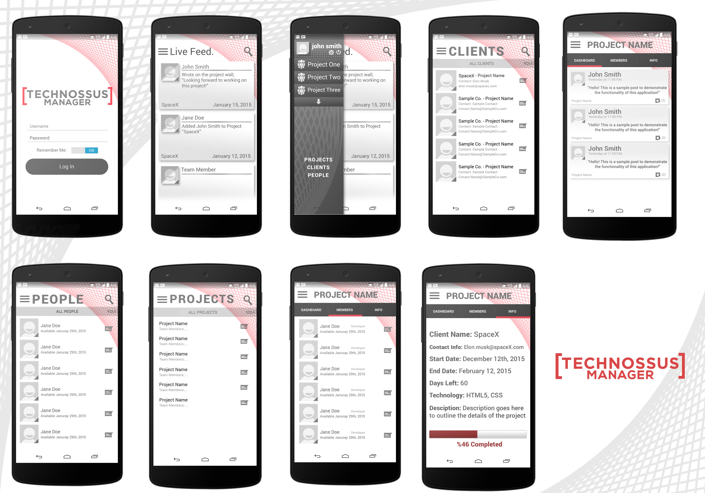

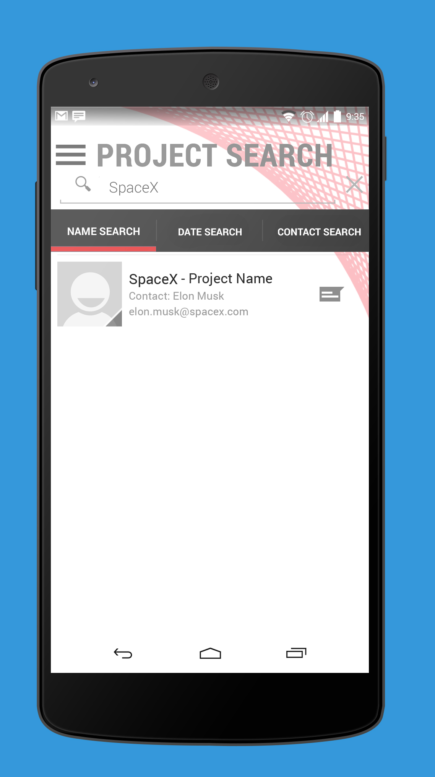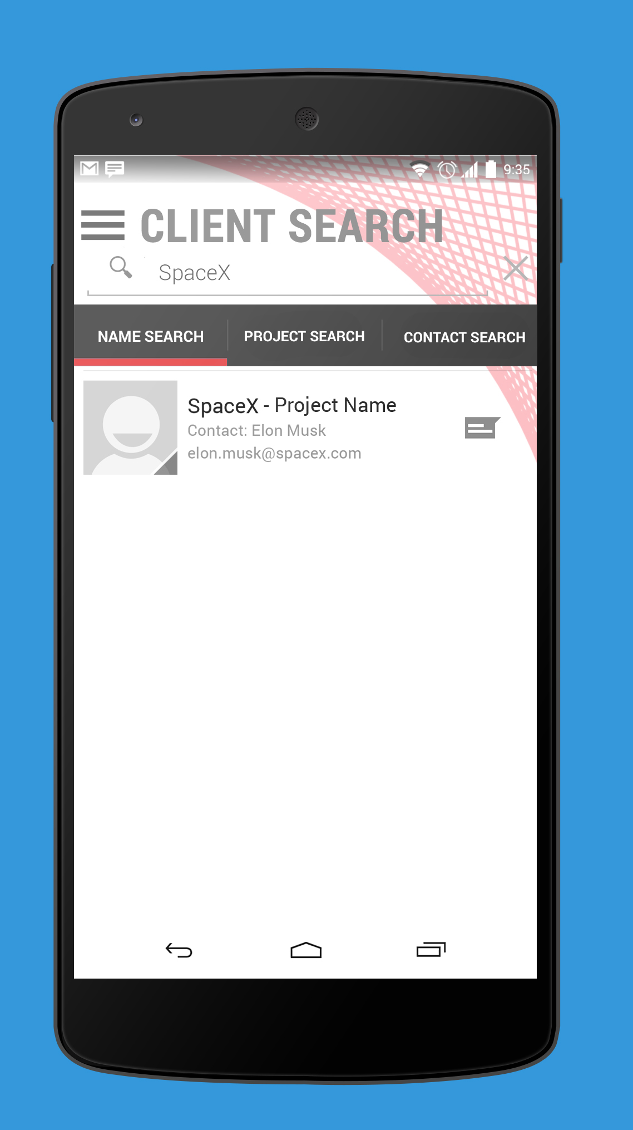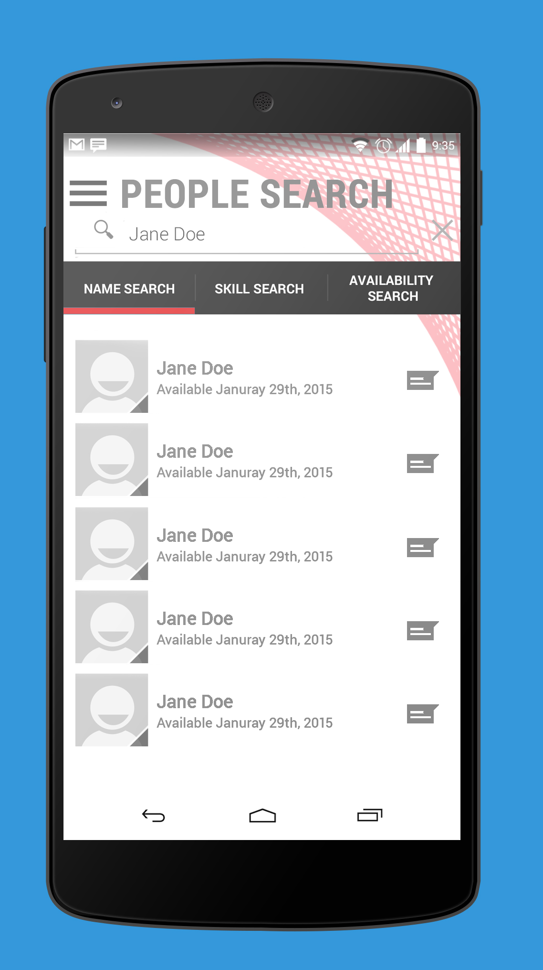

Use Cases

Consultant

Consultant – Login to the application

Consultant ­ Search for available project to work on

Consultant ­ Update Status of a project

Consultant – View current availability of coworker

Consultant – View all projects for a certain client

Consultant – Use sidebar to access the project list

Consultant – Use sidebar to access the client list

Consultant – Use sidebar to access the people list

Consultant – View personal information of fellow employee

Consultant – View information on a certain project

Consultant – View available information on a selected client

Manager

Manager ­ Query consultant with specific skills

Manager ­ Update Status of a project

Manager – View personal information of an employee

Manager – View availability of an employee

Manager – Use sidebar to navigate to the project list

Manager – Use sidebar to navigate to the client list

Manager – Use sidebar to navigate to the people list

Manager – View all projects that a certain client has ongoing

Manager – Post on a project page for employees to see

Functional Requirements Specification

Objectives

The application will provide managers with portable access to background information for their current projects, as well as any information regarding the people working on those projects and the clients that are the recipients of the project. The application will communicate with a pre-existing web based system, and present the functionality and information from this system in a mobile accessible format. The application will allow access to information vital to placing individuals on project teams and monitoring the communication within these teams. This system will be adaptable to various mobile platforms in the future and will be written in the C# programming language.

|  |  |
| --- | --- |
|  | Functionality |
| This system shall… | Communicate with the pre-existing web based system. |
| This system shall… | Provide information regarding clients and their ongoing projects. |
| This system shall… | Provide information regarding employees including contact info and availability. |
| This system shall… | Provide information regarding projects, including any information posted to a project page by team members, which client the project is for, and a list of team members. |
| This system shall… | Quick links for accessing lists of people, clients, and projects with ease. |
| This system shall… | Communicate with the existing system to approve user credentials for login. |
| This system shall… | Be written in the C# programming language using the Xamarin framework. |
| This system shall… | Be adaptable to multiple mobile operating systems in the future. |
| This system shall… | Allow access to user profiles including availability, contact info, and an image of the individual. |
| This system shall… | Provide a text search for users to find specific people, clients or projects. |
| This system shall… | Allow users to view employee skills to determine if they would match the needs of a particular project. |
| This system shall… | Allow the user to logout using a button in the sidebar |

Walkthrough/User Story

Upon accessing the application, all users are greeted with a login screen. Upon entering their credentials, the user will be introduced to a live feed of all posts and actions conducted on any of their current project pages (i.e. if a manager or employee is working on an application for SpaceX, that manager or employee’s feed will include the actions from that particular project page. At this point, there are many different routes that a user can take through the application. The user may use the search functionality to find project, people and clients, providing them with direct access to any information within the system. Or, the user may use the sidebar to navigate through the application. Swiping from the side of the screen accesses the sidebar, outlined on the sidebar is basic information about the current user, current projects, and quick links for navigation through the application. Pressing any of the quick links will take you to a list of items of that particular type (i.e. pressing clients takes you to the client feed, projects takes you to project feed, etc.). Upon accessing a certain project, the user can view any posts made to that project’s page and information about the project. When viewing a client page, the user will have access to contact information for that client and any active projects that are currently ongoing with Technossus. Upon viewing a specific person’s page, the user will be able to view an image of the individual, as well as basic contact information and their availability. At any time, the user can access the sidebar and logout by using the provided button.

Software Qualities and Non­Functional Requirements

The Technossus Manager application must include the following software qualities: I. Reliability

A. Accuracy

1. This application should provide the most up­to­date information available at the time such that when higher level management makes decisions, the information that they act on is valid.( how will your application achieve it? Just 2 lines)

B. Error Tolerance

1. This tool is of internal use, and therefore some errors can be allowed. Errors on important information like contact, personal information is not allowed. But small amount of post mistake is acceptable. A large amount of errors may cause employees to not use this specific platform, so it is important to keep this application error free as possible.

C. Simplicity

1. This application should only provide the most concise data that is requested, as this is a mobile platform, and is mostly used for quick purposes. We will find an efficient way when connect the front-end to the back-end which is already written and write query that works efficiently.

II. Interoperability

A. Data Commonality

1. This application share the same data as with the main web interface that is currently setup. Since the back-end is the same with the web, the data coming in is the same. The mobile app is simplified version of the Web; we have to make sure we process the data correctly.

III. Flexibility

A. Expandability

1. As the Technossus grows, they may need to add additional features to this application that extends past its original purpose.

B. Modularity

1. It is of great focus to create a generou gui that will enable the growth of the application as needed by the company. ( This is not clear )

IV. Correctness

This section can be improved by removing generic qualities and adding the ones that can explained in context of the app. Also remember that if you mention a quality in the requirement document your final deliverable should live upto those qualities. So choose your qualities wisely. ( for example : If I plan to add a help utility with my software I will add the quality learnablity)

A. Completeness

1. The finish of this project within the allotted time is a top goal of this team, but client noted that if not completed, can/will be picked up internally by engineers.

B. Consistency

1. There is a major importance on the aesthetics of mobile applications; we must provide a consistent experience throughout the functionality of the application.

Assumptions and Risks

The following are assumptions about Technossus Manager,

● Beyond the scope of our course schedule, Technossus will continue to maintain this application in­house

● The majority of the data is already present in their web application, and minor additional details need to be added in terms of database structure

● This application will only be used internally by Technossus employees

● This application can be used anywhere there is internet access

● Authentication will be handled with previous infrastructure already in place (Shoud’t the app redirect to the login page? )

● The only user generated information will be from the posting on projects

The following are major risks for Technossus Manager,

● Access of internal information to the outside

● Loss of personal credentials through application

* The part about security not clear. Are you going to redirect to a login page on a web site and direct back to the applicaton ?

Priorities and Implementation Phases

I. Must Have

A. Complete information from database

B. Search ability of employees

II. Should Have (A & B are qualities not features , only add features if any )

A. Fluid user experience

B. Aesthetically pleasing

C. Ability to post and comment on projects

III. Nice to Have

A. Advanced/Smart queries

Future Directions and Expected Changes

As this will be the official internal application of Technossus, we can expect feature requests from all levels to help them with their daily tasks. Some additional features that are likely to be suggested will be notifications for received messages on the phone itself, more customization of profiles, the ability to input more detailed information about project, messaging services within the application itself, clock in/out ability, GPS tracking of location for information purposes, and video conferencing abilities. In addition, we are currently target to Android device. Thus, we are expected to develop IOS version in the future.